Scatter to Serve God & Neighbor

Welcome to all! We gather to praise God for the innumerable blessings given

to us and to grow deeper in the Spirit. Joyfully, let us lift our hearts to God.
Estimate of Giving for 2023
It is that time of year when we are all asked to take a prayerful look at our giving and to make a financial commitment for CHUMC ministries. “Estimate of Giving cards” are provided in the Commons (or use tare off from the December newsletter) for your convenience to fill out and send to CHUMC, or put it in the weekly offering plate, during December so that we have your pledge by the end of December. We plan to have a luncheon after church on Sunday, February 12th (weather permitted), to celebrate our statement of faith to support the ministries of CHUMC.

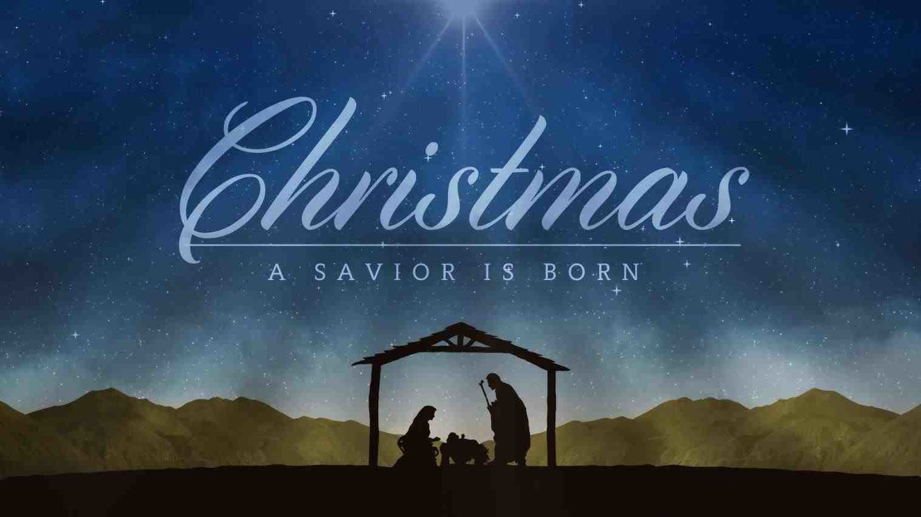

DIRECTORY OF CHESTNUT HILL UNITED METHODIST CHURCH
Sharma Lewis | Richmond Area Resident Bishop
Denise Bates | Mountain View District Superintendent
Adam White | Minister
Erin Long | Associate Minister
Monica Campbell | Administrative Assistant
Heather Wilson | Director of Music Ministry
Judy Martin | Bookkeeper
Judy Robertson | Lay Leader

Chestnut Hill United Methodist Church
10:30 a.m. ~ December 25, 2022 ~ Christmas Day
Our ministry vision for the Virginia Annual Conference is “to be disciples of Jesus Christ who are lifelong learners, who influence others to serve.”

Welcome! Join us in worshiping God!

Prelude
Welcome and Ministry Announcements
Welcome in the name of Christ our Lord. Please register your attendance,
printing your name, address, phone, and email, on the attendance pad provided on your pew. Thank you for silencing cell phones as we gather to worship God.
Invocation
Greeting
When Christmas morn is dawning,
I wish that I could be
There by the manger cradle,
God’s Son, newborn to see.
How kind of you our Savior,
for us to come to earth,
O may we not by sinning,
despise your lowly birth.
We need you, O Lord Jesus,
to be our dearest friend,
Your love will guard and guide us
and keep us to life’s end. (Elisabeth Ehrenborg-Posse, 1856)
*Singing Our Faith # 246 “Joy to the World”

*Opening Prayer
O God, you make us glad by the yearly festival of the birth of your only Son Jesus Christ: Grant that we, who joyfully receive him as our Redeemer, may with sure confidence behold him when he comes to be our Judge; who lives and reigns with you and the Holy Spirit, one God, now and for ever. Amen.

Anthem “Love Has Come”
Greeting Friends and Neighbors
Scripture Lessons Luke 2:1-20 and John 1:1-14
The Word of God for the people of God.

Thanks be to God.
Singing Our Faith # 245 “The First Noel”
The Good News “Surprise!”

Bringing Forward God’s Tithes and Our Gifts
*Doxology # 95 Praise God from whom all blessings flow; praise him, all
Creatures here below; praise him above, ye heavenly host; praise Father, Son, and Holy Ghost. Amen.
*Prayer of Thanksgiving
Sharing of Joys and Concerns
The Lord’s Prayer

Our Father, who art in heaven, hallowed be thy name. Thy kingdom come,
Thy will be done on earth as it is in heaven. Give us this day our daily bread and forgive us our trespasses, as we forgive those who trespass against us. And lead us not into temptation, but deliver us from evil. For thine is the kingdom, and the power, and the glory, forever. Amen.
Prayer of Consecration
Breaking Bread
Prayer after Communion
Eternal God, we give you thanks for this holy mystery in which you have given yourself to us. Grant that we may go into the world in the strength of your Spirit, to give ourselves for others, in the name of Jesus Christ our Lord. Amen.
*Singing Our Faith # 251 “Go, Tell It on the Mountain”
*Blessing and Dismissal
*Postlude

**Calendar**
Monday, 12/26 |  | Office Hours: 10:00 a.m.-2:00 p.m.
Tuesday, 12/27 | 10:00 a.m. | Martin Visitation~CHUMC
 | 11:00 a.m. | Martin Funeral~CHUMC  Burial following in Fort Hill Memorial Park
Saturday, 12/30 |  | Church Office Closed
**Looking Ahead on the Calendar **
Thursday, 1/5 | 6:30 p.m. | Choir

Hospital: Lynchburg General: Barbara LeFew

(North Carolina) Beverly Franklin


Beryl Elizabeth Martin
September 21, 1926 - December 19, 2022
Chestnut Hill United Methodist Church extends Christian love and sympathy to the family of Beryl Elizabeth Martin and especially to her nephew, Bill Graham, and her sister-in-law, Margaret Martin.


For the Grocery Cart:
December ~ Laundry Detergent, Dishwashing Liquid, & side items for a Christmas meal. Place donations in the grocery cart, located in the Commons. No “baked goods” of any kind!
Christmas Offering
We have set a goal of $6,000, with 10% going to Park View Community Mission,
and 90% toward HVAC repair/replacement for social hall and educational building. Envelopes are placed in the pew racks.
Mitten Tree Trunk
The Mitten Tree Trunk has been placed in the Commons for donations of mittens, gloves, hats, scarves, and socks. These will be distributed as needed by HumanKind, so they can be purchased after Christmas.

**Calendar**
Monday, 12/26 |  | Office Hours: 10:00 a.m.-2:00 p.m.
Tuesday, 12/27 | 10:00 a.m. | Martin Visitation~CHUMC
 | 11:00 a.m. | Martin Funeral~CHUMC  Burial following in Fort Hill Memorial Park
Saturday, 12/30 |  | Church Office Closed
**Looking Ahead on the Calendar **
Thursday, 1/5 | 6:30 p.m. | Choir

Hospital: Lynchburg General: Barbara LeFew

(North Carolina) Beverly Franklin

Beryl Elizabeth Martin
September 21, 1926 - December 19, 2022
Chestnut Hill United Methodist Church extends Christian love and sympathy to the family of Beryl Elizabeth Martin and especially to her nephew, Bill Graham, and her sister-in-law, Margaret Martin.

For the Grocery Cart:
December ~ Laundry Detergent, Dishwashing Liquid, & side items for a Christmas meal. Place donations in the grocery cart, located in the Commons. No “baked goods” of any kind!
Christmas Offering
We have set a goal of $6,000, with 10% going to Park View Community Mission,
and 90% toward HVAC repair/replacement for social hall and educational building. Envelopes are placed in the pew racks.
Mitten Tree Trunk
The Mitten Tree Trunk has been placed in the Commons for donations of mittens, gloves, hats, scarves, and socks. These will be distributed as needed by HumanKind, so they can be purchased after Christmas.


Chestnut Hill
United Methodist Church

Making disciples of Jesus Christ
for the transformation of the world.
You are welcome at Chestnut Hill UMC.

4660 Fort Avenue ~ Lynchburg, Virginia 24502
Church: 434-239-8423
Minister’s Cell: 434-944-7723, Minister’s Email: awhite@ves.org
Associate Minister’s Cell: 1-502-489-0200
Associate Minister’s Email: healingsolutions12@gmail.com
chestnuthillumc@comcast.net ~ on the web at chestnuthillumc.net
Find us on Facebook: Chestnut Hill United Methodist Church

